(c) Problem Statement
Given a publicly available hormonal disorder dataset containing demographic, lifestyle and clinical features (e.g., age, BMI, physical activity, diet quality, sleep duration, stress level and relevant clinical measurements), the proposed system aims to predict whether a non-invasive lifestyle intervention is likely to improve hormonal health outcomes by generating a binary or multi class prediction along with feature importance scores for clinical interpretation. The primary challenges include missing values, class imbalance, heterogeneous patient characteristics and varying contributions of lifestyle factors, which may affect prediction performance and model generalization. The proposed Lifestyle Attention Neural Network (LANN) will be evaluated using Accuracy, Precision, Recall, F1score and its performance will be compared against baseline models such as Logistic Regression, Random Forest, XGBoost and a standard Deep Neural Network without the proposed attention module.

Element | Description
Input | A publicly available hormonal disorder dataset containing demographic, lifestyle, and clinical features such as age, gender, BMI, physical activity, diet quality, sleep duration, stress level, blood glucose, blood pressure, and relevant hormonal indicators.
Output | A binary or multi-class prediction indicating the effectiveness of non-invasive lifestyle interventions on hormonal health (e.g., improved/not improved or low/moderate/high risk), along with feature importance scores for interpretability.
Constraint | Clinical datasets may contain missing values, class imbalance, heterogeneous patient characteristics, and varying influence of lifestyle factors, which can affect prediction accuracy and model generalization.
Success Criterion | The proposed Lifestyle Attention Neural Network (LANN) should achieve higher Accuracy, Precision, Recall, F1-score, and ROC-AUC than baseline models such as Logistic Regression, Random Forest, XGBoost, and a standard Deep Neural Network without the proposed attention module.

(d) Proposed System Architecture

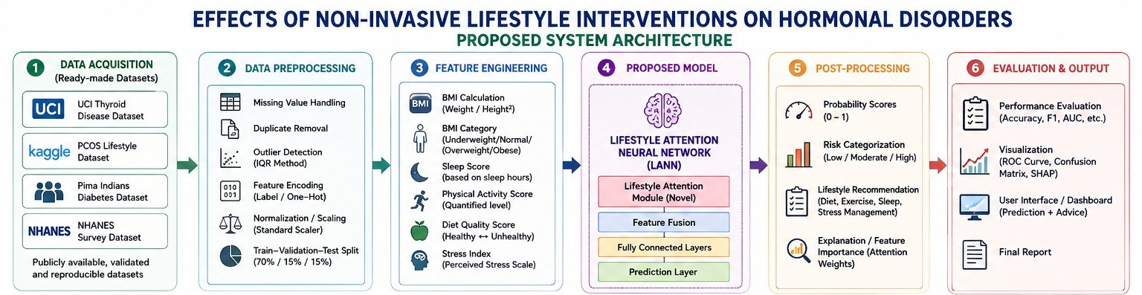

Justification for Each Design Choice

Design Component | Justification
Public Dataset | Publicly available datasets (e.g., UCI, Kaggle, NHANES) provide standardized, reproducible, and validated clinical data, enabling fair comparison with existing studies.
Missing Value Handling | Clinical datasets often contain incomplete records. Imputation preserves useful information while reducing bias caused by discarding samples.
Outlier Detection (IQR Method) | Removes extreme observations that may arise from measurement errors or data entry mistakes, improving model robustness.
Feature Encoding | Converts categorical variables into numerical representations suitable for machine learning algorithms.
Normalization (StandardScaler) | Standardizing features ensures equal contribution during optimization and improves convergence of neural networks.
Lifestyle Feature Engineering | Derived features such as BMI, Diet Score, Sleep Score and Physical Activity Score summarize clinically meaningful lifestyle information, potentially improving prediction quality. Hypothesis: Composite lifestyle indicators capture health status better than raw variables alone.
Lifestyle Attention Module (Novelty) | Hypothesis: Lifestyle factors contribute differently to hormonal disorders. An attention mechanism learns feature-specific importance weights, allowing the model to emphasize influential factors (e.g., BMI, sleep quality, physical activity, diet) instead of treating all features equally. This is expected to improve prediction accuracy while providing interpretable feature importance.
Feature Fusion | Combines weighted lifestyle features into a unified representation before classification, preserving interactions among multiple health indicators.
Fully Connected Layers | Learn complex nonlinear relationships between engineered lifestyle features and hormonal disorder outcomes.
SHAP Explainability | Provides feature level explanations for each prediction, improving transparency and supporting clinical interpretation.

Planned Experimental Setup

Dataset
- Public hormonal disorder dataset (e.g., UCI Thyroid Disease, Pima Indians Diabetes).

Data Split Strategy
- Training Set: 70%
- Validation Set: 15%
- Testing Set: 15%

Evaluation Metrics
- Accuracy
- Precision
- Recall
- F1-score
- Confusion Matrix

Baseline Models
The proposed model will be compared against:
- Logistic Regression
- Decision Tree
- Random Forest
- XGBoost
- Standard Deep Neural Network (without the Attention Module)

Software Environment
- Intel Core i5
- 16 GB RAM
- Google Colab (Tesla T4 GPU)
- Python 3.x
- TensorFlow/Keras or PyTorch
- Scikit-learn
- Pandas
- NumPy
- SHAP

Ablation Studies
Experiment | Purpose
Baseline Deep Neural Network | Establish baseline performance.
DNN + Lifestyle Feature Engineering | Evaluate the contribution of engineered lifestyle features.
DNN + Lifestyle Attention Module | Assess the effectiveness of the proposed attention mechanism.
Full Proposed Model (Feature Engineering + Attention) | Evaluate the complete architecture.
Proposed Model without SHAP vs. with SHAP | Demonstrate explainability without affecting predictive performance.

(e) Feasibility Note
The proposed system is a software-based machine learning framework that analyzes publicly available hormonal disorder datasets to predict the effectiveness of non-invasive lifestyle interventions. Since the study relies on open-source datasets (e.g., UCI, Kaggle, or NHANES), no patient recruitment, ethical approval for data collection, or specialized medical equipment is required, making the project feasible within the available timeframe.
The selected dataset is expected to contain hundreds to thousands of patient records with demographic, clinical, and lifestyle-related features. Data preprocessing, feature engineering, model training, and evaluation will be performed using Python with libraries such as TensorFlow/Keras (or PyTorch), Scikit-learn, Pandas, and NumPy. Training will be conducted on a standard personal computer or Google Colab with GPU support if required. Based on the dataset size and model complexity, the estimated training time is expected to range from 5 to 30 minutes per experiment.
Potential risks include missing or imbalanced data, limited lifestyle-related features, and model overfitting. To address these challenges, appropriate preprocessing techniques such as missing value imputation, feature scaling, class balancing and regularization methods (dropout and early stopping) will be applied. If the selected dataset does not adequately support the proposed lifestyle analysis, an alternative publicly available hormonal disorder dataset (e.g., thyroid disease, diabetes, or NHANES) will be used. These measures ensure that the proposed work is technically feasible, reproducible, and achievable within the project's duration.

